**TOTAL FRAMES IN THE TECH QUIZ APP**

Overall , the project "**Tech Quiz App**" , will have following frames:

**1. SplashScreenFrame**

**2. LoginFrame**

**3. AdminOptionsFrame**

**4. StudentOptionsFrame**

**5. SetPaperFrame**

**6.SetQuestionsFrame**

**7.EditPaperFrame**

**8.EditQuestionsFrame**

**7.RegisterStudentFrame**

**8.ViewScoresFrame**

**9.ViewSingleStudentScoreFrame**

**10.ViewAllStudentsScoreFrame**

**11.PaperSelectionFrame**

**12.TakeTestFrame**

**13.ViewScoresFrame**

**14.ChangePasswordFrame**

**COMMON SCREENS**

**============================================================================================**



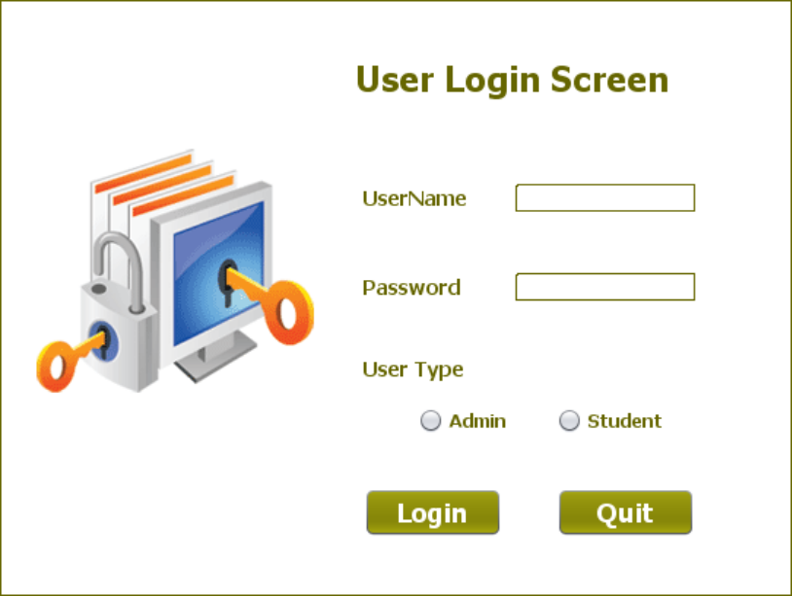

**ADMIN SCREENS**

**============================================================================================**



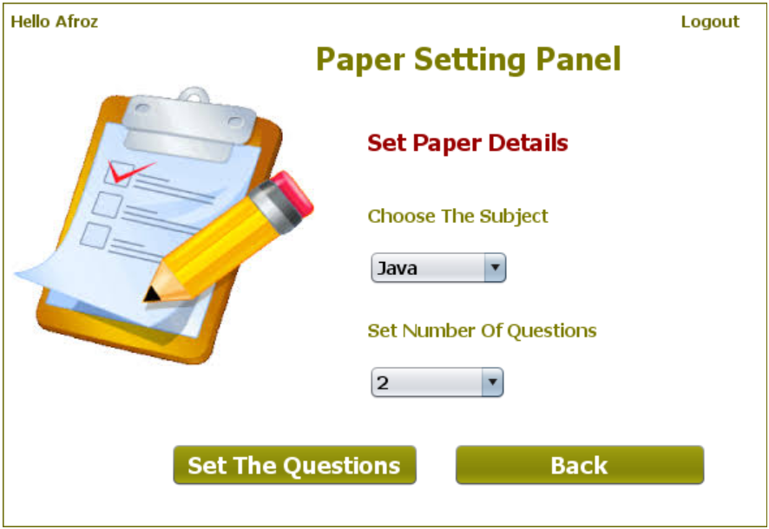

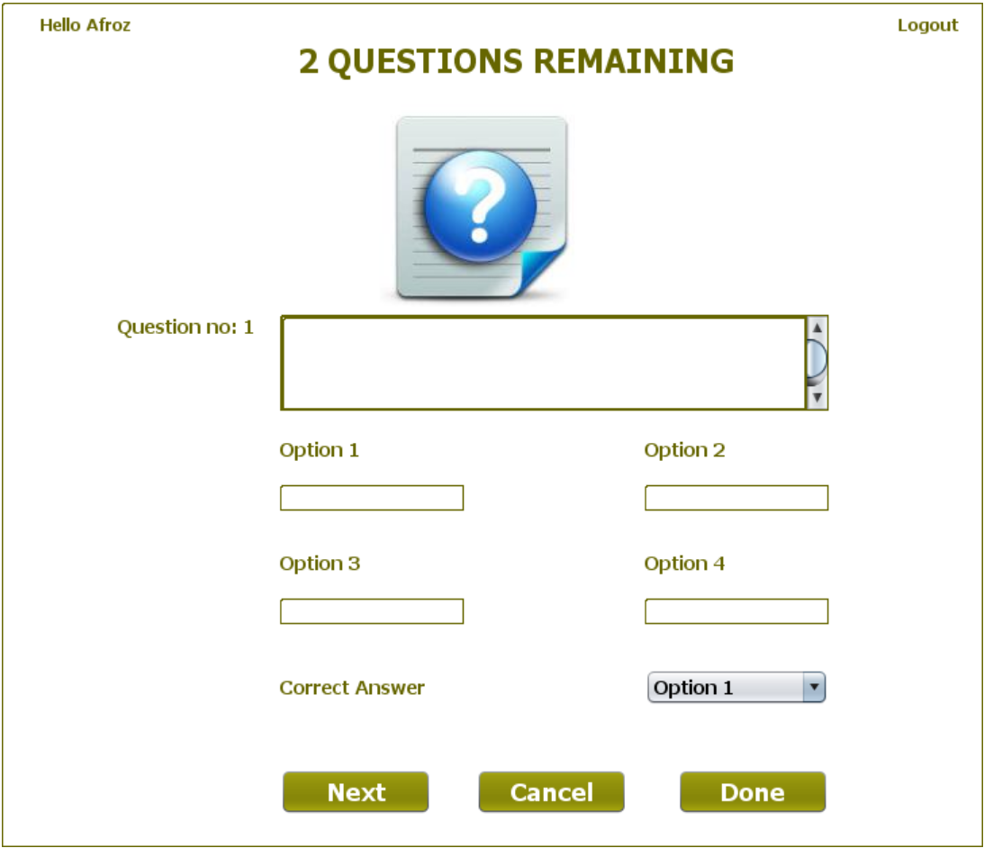

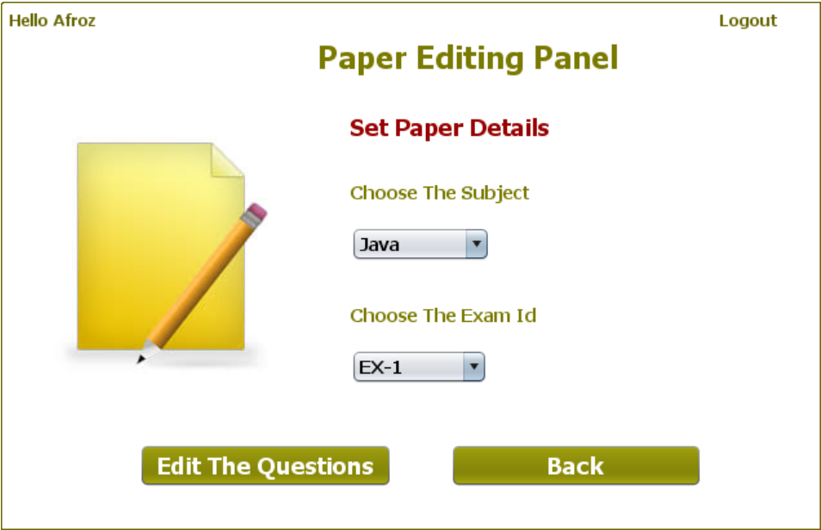

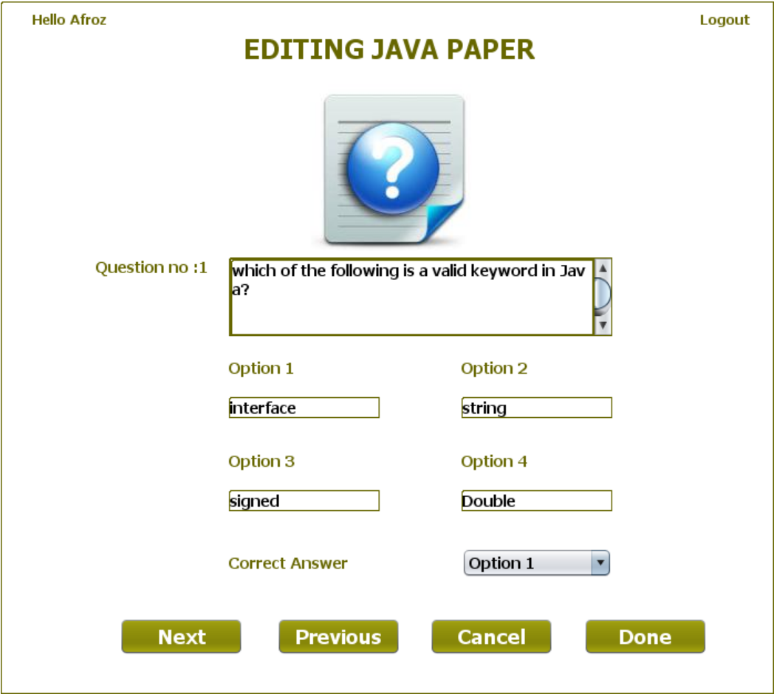

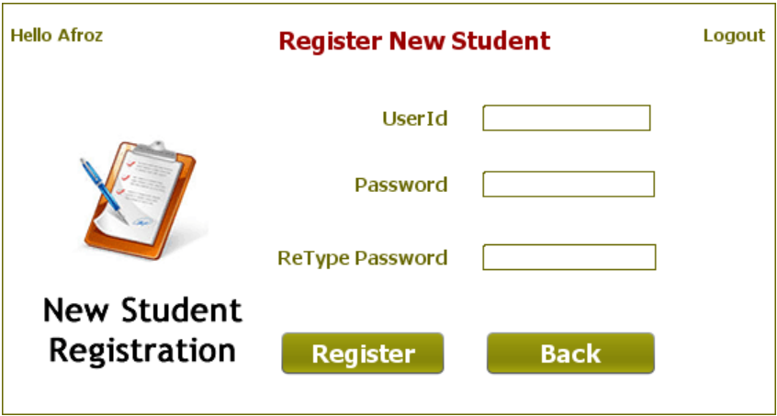

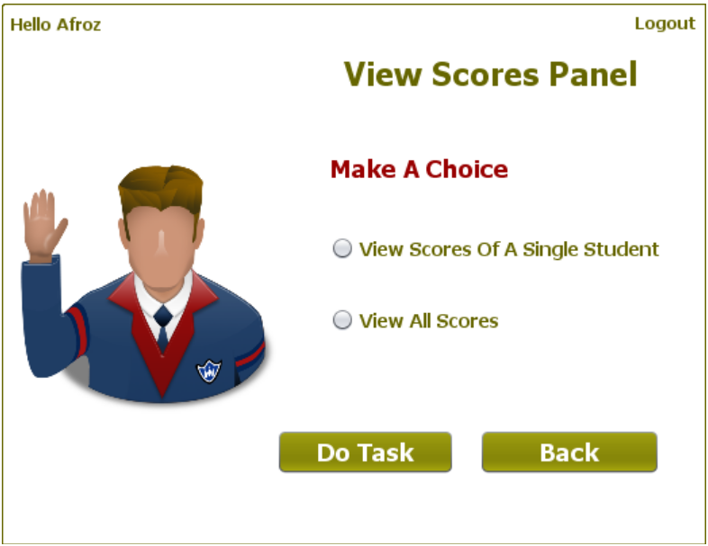

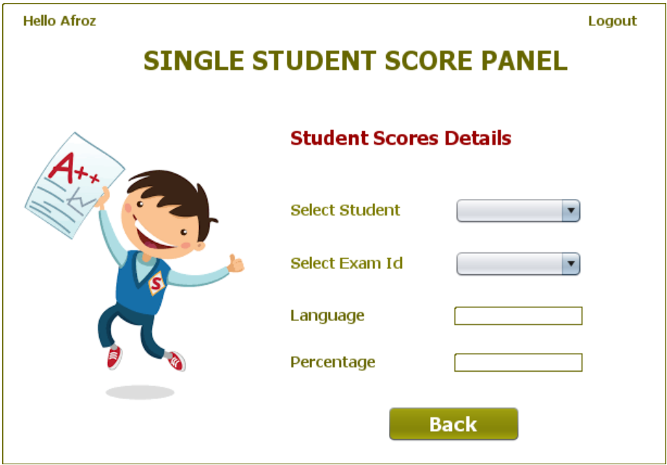

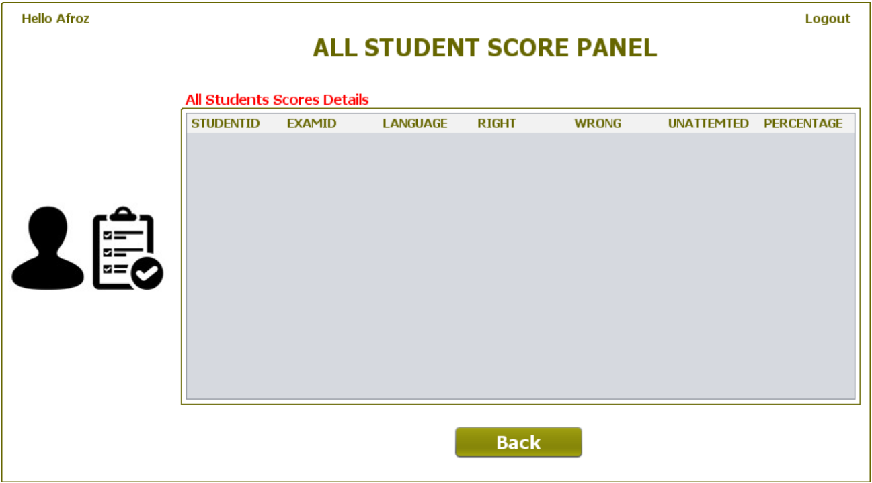

**STUDENT SCREENS**

**============================================================================================**



